
APPLICATION FOR APPOINTMENT

Please email your application to:
Brendon Fiebig, Principal
principal@tatuanui.school.nz

PERSONAL DETAILS
Full name
Preferred Title
Address
Telephone (Home)
Telephone (Work)
Telephone (Mobile)
Email
Teacher Registration Number and expiry date:
MoE Number:
Please Attach: colour photocopy of driver’s license to your application

QUALIFICATIONS
Teaching Qualifications | Institution | Year Awarded

SUMMARY OF POSITIONS HELD IN THE LAST 10 YEARS
School | Position held | Reason for leaving | Period employed

REFEREES
Please provide the names of three people who could act as referees for you.
Please ensure your selected referees are able to attest to your professional competencies.
Referee 1
Full name
Address
Contact Phone number
Email
Relationship to applicant
Years known to applicant

Referee 2
Full name
Address
Contact Phone Number
Email
Relationship to applicant
Years known to applicant

Referee 3
Full name
Address
Contact Phone Number
Email
Relationship to applicant
Years known to applicant

Applicant’s Self-Assessment.

SELF REFLECTION:
What do you consider to be the 3 main qualities / characteristics that present you as a quality applicant for the position of teacher at Tatuanui School?

SELF REFLECTION:
When you are faced with a dilemma of practice - be it a child’s achievement, a professional quandary, or a difference of opinion, how do you respond, and endeavour to find a solution?

SELF REFLECTION:
How do you manage the work/home life balance?

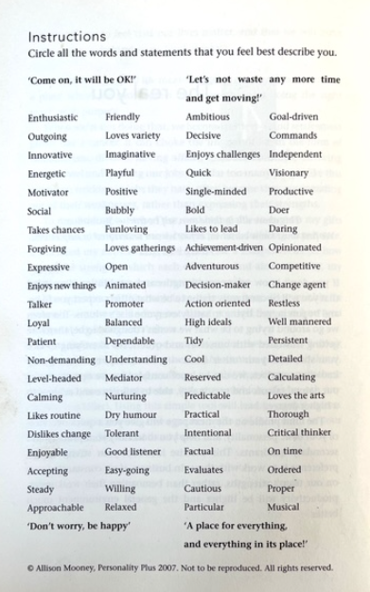

GENERAL
Have you ever been convicted of an offence against the law? | Yes ⬜ No ⬜
If ‘YES’, please supply relevant details:

I give permission for Tatuanui School Board of Trustees to check my record with the New Zealand Police. | Yes ⬜ No ⬜
To the best of my knowledge the statements in my Application documents are true and accurate.
I give permission for these claims to be verified.
I understand that the conditions of my employment may be jeopardized if the claims are found to be false.

I give permission for the Tatuanui School Board of Trustees to gather information from any person or organisation that the Board deems necessary in relation to my application. | Yes ⬜ No ⬜

Applicant Signature: …………………………………………..…………………….. Date: ………………..…………………………..

